

Dream Weaver Marina Fleet
Group Members
s.no | Student ID | Student Name
1 | 1706417 | Umme Hani
2 | 1717977 | Isha Amir
3 | 1706464 | Khizer Abdullah
4 | 1717990 | Shariq Ali
5 | 1717961 | Ahmed

Project advisor
Muhmmad Ibrahim

Aptech Computer Education
Korangi Center

ACKNOWLEDGEMENT

First of all we would like to thank ALLAH the almighty who make us able to complete this project.
After that we would like to express profound gratitude to our internal project advisor, Center
Faculty, Sir Ibrahim Warsi, for her precious support, back-up, supervision and useful suggestions throughout this project. Her moral support and continuous help enabled us to complete our work successfully. We are also highly thankful to the Center Management for their valuable suggestions, healthy analysis and support throughout this project. We are grateful to the faculty members of Aptech Korangi Center who were always there to help us despite of their personal workload. We are as ever, especially indebted to our parents for their love and support throughout our life. We also wish to thank our classmates, friends and all the individuals or groups that were involved in this project by any mean.

- Umm-e-Hani
-Isha Amir
-Khizer
-Ahmad
-Sharik

Summary

marina Fleet is a professional marine services company dedicated to providing reliable and efficient fleet management solutions. The company offers a wide range of services, including vessel operations, maintenance, logistics support, and maritime transportation.
By focusing on safety, quality, and operational excellence, Marina Fleet helps clients improve performance while reducing operational risks and costs. Its experienced team uses modern technology and industry best practices to ensure smooth and dependable
services. Committed to customer satisfaction and sustainable operations, Marina Fleet strives to build long-term partnerships with clients by delivering tailored solutions that meet the evolving needs of the maritime and offshore industries.

HOME PAGE
The Marina Fleet home page provides an attractive introduction to the company and its
marine services. It features a modern design with high-quality images of yachts and highlights the company’s commitment to delivering safe, comfortable, and memorable sea experiences. The homepage presents key sections such as featured yachts, pricing
plans, popular destinations, and service highlights, allowing visitors to quickly explore available options. It also includes easy navigation, contact information, and calls to action that encourage users to book a trip or learn more about the company’s offerings. Overall, the homepage is designed to create a professional first impression and provide visitors with all the essential information in a simple and engaging way.

Marina Fleet – Features and Functionalities

- User-Friendly Interface – The website has a clean and easy-to-use design for smooth navigation.
- Responsive Design – It works well on desktops, tablets, and mobile phones.
- Navigation Menu – Users can easily access pages such as Home, About, Services, Fleet, and Contact.
- Fleet Information – Displays details about available boats, yachts, or marine vessels.
- Service Information – Explains the marine services offered by the company.
- Image Gallery – Shows high-quality images of the fleet and marine activities.
- Contact Section – Provides contact details and a form for customer inquiries.
- Call-to-Action Buttons – Buttons like Book Now, Contact Us, or Learn More encourage user interaction.
- Fast Performance – Pages load quickly for a better user experience.
- Professional Layout – The website uses a modern design that creates a strong first impression and improves reade

Number Of Index ACKNOWLEDGEMENT
................................................................................................................................... 2
Summary:
.......................................................................................................................................
............... 2 Home Page:
.......................................................................................................................................
........ 3 Features of functionalities:
................................................................................................................... 3
Introduction
.......................................................................................................................................
........... 7 Key
Features:........................................................................................................................
..................... 7 User-Friendly Experience:
..................................................................................................................... 8
Objective
.......................................................................................................................................

................ 8 • The Objective of this program is to give a sample project to work on real life projects. These applications help you build a larger more robust application.
..................................................................... 8 • The objective is not to teach you topic but to provide you with a real life scenario and help you create basic applications using the tools.
..................................................................................................... 8 • You can revise these chapters before you start with the project. ........................................................

8 • These programs should be done in the Lab sessions with assistance of the faculty if required. ......... 8 • It is very essential that a student has a clear
understanding of the subject. ....................................... 8 • Kindly get back @ eprojects@aptechfze.ae in case of any doubts regarding the application or its objectives.
.......................................................................................................................................
.............. 8 Technology Used
.......................................................................................................................................
.... 9 Website Future .......................................................................................................................................
...... 9 Shopping Mall Website Features
.......................................................................................................... 9 Site
Requirement
.......................................................................................................................................
. 11 Website structure
.......................................................................................................................................
12 Bootstrap Grid System
................................................................................................................................ 12
Process Diagram
.......................................................................................................................................
... 13 Databasa Design
.......................................................................................................................................
... 13 Website functionalities explanation:
.......................................................................................................... 14 Admin
Module:
.......................................................................................................................................
.... 14 Client Module:
.......................................................................................................................................
..... 14 Website Figure
.......................................................................................................................................
..... 15 Home-2
.......................................................................................................................................
............ 16 Admin Site Figures
......................................................................................................................................
23 Code Figures
.......................................................................................................................................
......... 27 Conclusion:
....................................................................................................................................... ........... 32 5 | Page

Web Site Figure
Home 1
....................................................................................................................................... ................. 15 Home 2
....................................................................................................................................... ................. 16 Figure 3
.......................................................................................................................................
................ 16 Figure 4
.......................................................................................................................................
................ 17 Figure 5
....................................................................................................................................... ................ 17 Figure 6
.......................................................................................................................................
................ 18 Figure 7
.......................................................................................................................................
................ 18 Figure 8
.......................................................................................................................................
................ 19 Figure 9
.......................................................................................................................................
................ 19 Figure 10
.......................................................................................................................................
.............. 20 Figure 11
.......................................................................................................................................
.............. 20 Figure 12
....................................................................................................................................... .............. 21 Figure 13
....................................................................................................................................... .............. 21 Figure 14
.......................................................................................................................................
.............. 22 Figure 15
....................................................................................................................................... .............. 22 Figure 16

Admin & Client Web Code figure
Figure 23
..................................................................................................................................................
... 27 Figure 24
..................................................................................................................................................
... 27 Figure 25
..................................................................................................................................................
... 28 Figure 26
..................................................................................................................................................
... 28 Figure 27
..................................................................................................................................................
... 29 Figure 28
..................................................................................................................................................
... 29 Figure 29
..................................................................................................................................................
... 30 Figure 30
..................................................................................................................................................
... 30 Figure 31
..................................................................................................................................................
... 31 Figure 32
.................................................................................................................................................. ... 31

Introduction Welcome to Marina Fleet

Marina Fleet is a trusted maritime service provider dedicated to delivering excellence in marine transportation and fleet management. We offer reliable, safe, and efficient solutions for individuals and businesses seeking high-quality marine services. With a commitment to professionalism, customer satisfaction, and operational excellence, Marina Fleet ensures every journey is smooth, secure, and memorable. Our experienced team and modern fleet are focused on providing outstanding service while maintaining the highest standards of safety and performance.

Objective


The Objective of this program is to give a sample project to work on real life projects. These applications help you build a larger more robust application. • The objective is not to teach you topic but to provide you with a real-life scenario and help you create basic applications using the tools. • You can revise these chapters before you start with the project. • These programs should be done in the Lab sessions with assistance of the faculty if required. • It is very essential that a student has a clear understanding of the subject. • Kindly get back @ eprojects@aptechfze.ae in case of any doubts regarding the application or its objectives.

Technology Used
In order to meet the requirement of our project we have used following underlying technologies

I. HTML 5
II.CSS 3
III. Bootstrap-5
IV.Java Script
VI.Font-Awesome

Filters:
Allow filtering based on categories, locations, availability, price range, and more.
User Registration and Authentication:
Account Creation: Users can create accounts using email or social media accounts.
Login and Password Reset:
Implement secure login functionality and offer password reset options.
Social Media Integration:
Allow users to log in with social media accounts like Facebook, Google, etc. Food Court Listings:
Comprehensive Details:
Provide detailed listings of food court vendors including name, description, cuisine type, location, opening hours, and contact information.
Search and Filter:
Users can search and filter vendors based on cuisine, location, availability, and price range. Movie Booking:
Showtime Listings:
Display comprehensive movie listings with showtimes, descriptions, and ratings.
Seat Reservation:
Allow users to view available seats and book movie tickets for specific dates and times.
Confirmation and Notifications:
Send confirmation and reminder notifications via email or SMS. Shop Listings:
Detailed Shop Information:
Provide comprehensive details about shops, including name, description, products/services offered, location, and contact information.
Search and Filter:
Enable users to search and filter shops based on product categories, location, and price range.
Modify or Cancel Reservations:
Allow users to modify or cancel their reservations easily.
Confirmation Process:
Notify users about the status of their reservations. Table Management for Food Court
: Track Table Availability:
Implement a system to track table availability and assign tables to reservations.
Table Capacity and Layout:
Allow vendors to set table capacities and configure layouts.

Menu Display for Food Court Vendors:
Showcase Menus: Vendors can display their food and beverage offerings, including prices and descriptions.
Reviews and Ratings:
User Reviews: Allow users to leave reviews and ratings for movies, food court vendors, and shops Rating System:
Implement a rating system for both vendors and individual menu items or products.
Restaurant and Shop Management:
Provide tools for restaurant owners or shop administrators to manage details, reservations, and inventory.

- Respond to Reviews
: Allow administrators to view and respond to user reviews.
- Analytics and Reporting:
Generate detailed reports on reservations, popular items, customer feedback, and more.
Mobile Responsiveness:
- Responsive Design
: Ensure the website is mobile-friendly and works seamlessly on various devices.

- Cross-Device Compatibility:
Allow users to make reservations, order food, and shop from their smartphones, tablets, or desktops.c

Site Requirement :
Since we have used bootstrap framework, it might have certain compatibility issues. We used the latest version of the framework and yet it has certain limitation. Below-mentioned is the compatibility chart for bootstrap. We highly recommend this website to be opened on “Google Chrome” due the best compatibility available.[5]
Website structure
Bootstrap Grid System Since we have used bootstrap framework for website. Grid layout[6] making technique have been used in our website. For review, I have mentioned the basic structure of grid system which we have used in our project. Table 1: Bootstrap Grid Information

Website functionalities explanation:
Functionalities are explained module wise:
Admin Module:

• Admin will have to login in the website to edit the features. • Will have the authority to ADD-EDIT-DELETE the content such as shopping centers (along with the list of few items it possess), counters at food court (can add some of the items). • Can add the details in the gallery section where the top brands item, or food image is presented • Can view the feedback received by the client users. • Will have the authority to ADD-EDIT-DELETE the movies which would be running on the multiplex also number seats available must be added. • Can view the tickets booked by the clients.

Client Module

: • The client can view the website but will not any login section. • They can view the data like list of the shopping centers, food courts, galleries, contact us details • They can provide the feedback • They can book the ticket online by providing the card details. (note if all the allocated seats are booked then it must not allow to book the tickets.) • Can search the name of the brands shops available, also in the food courts menu. • Can view the complete diagram of the mall • Can view the contact details. 14 | P a g e

Website figure
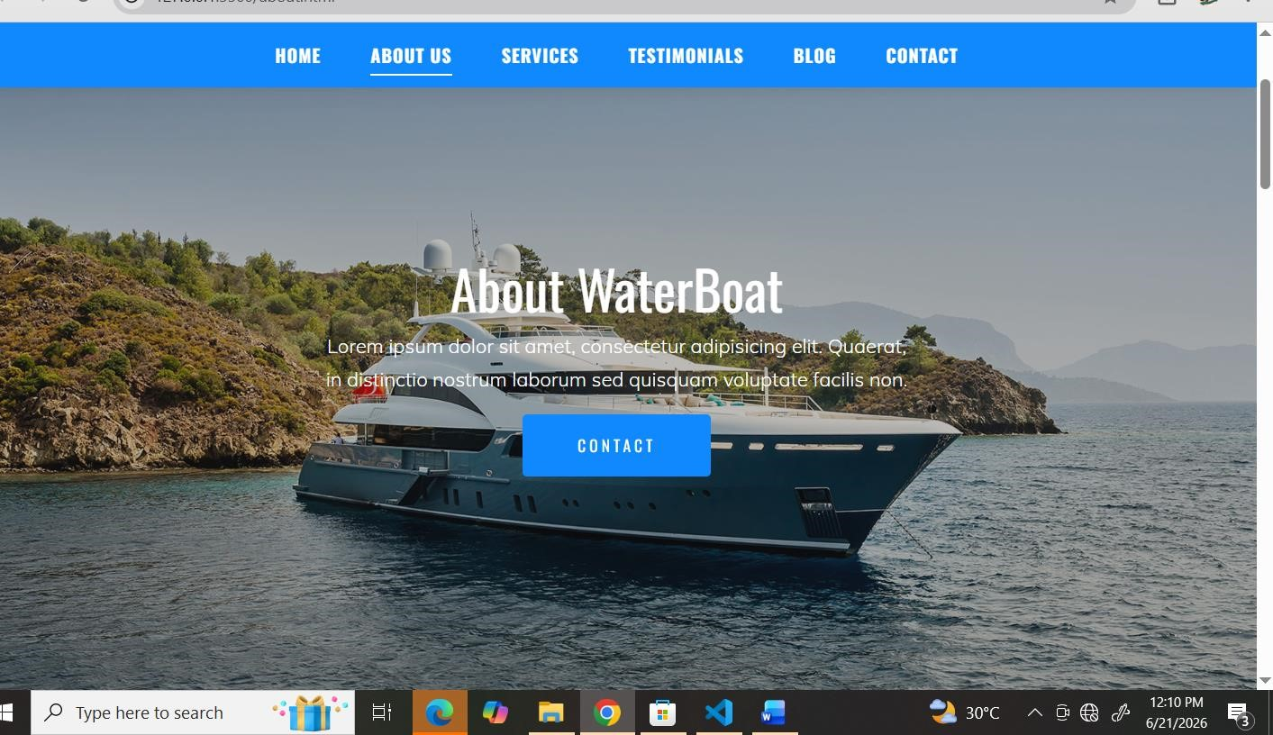

HOME PAGE

SERVICE
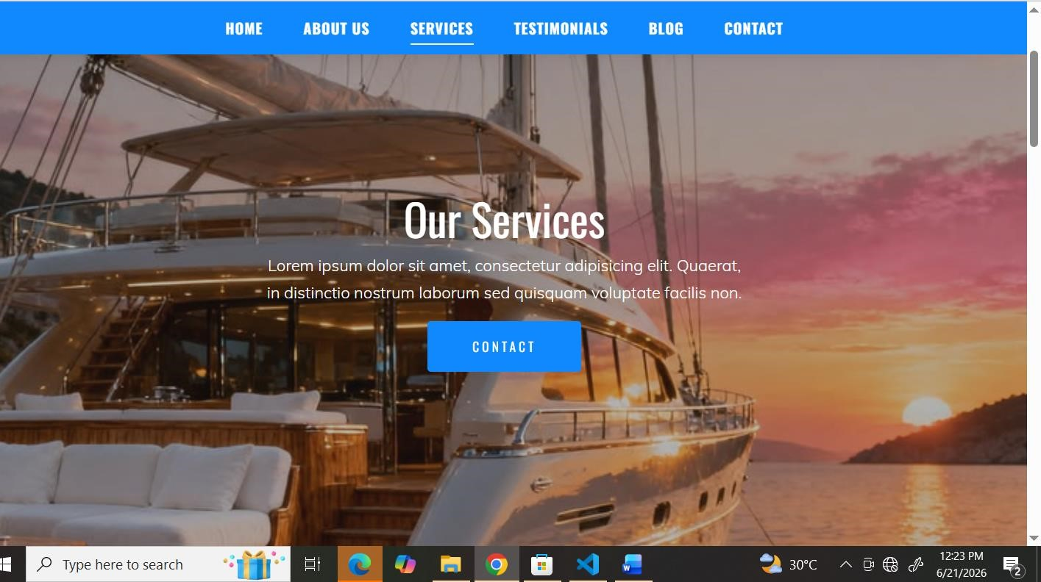

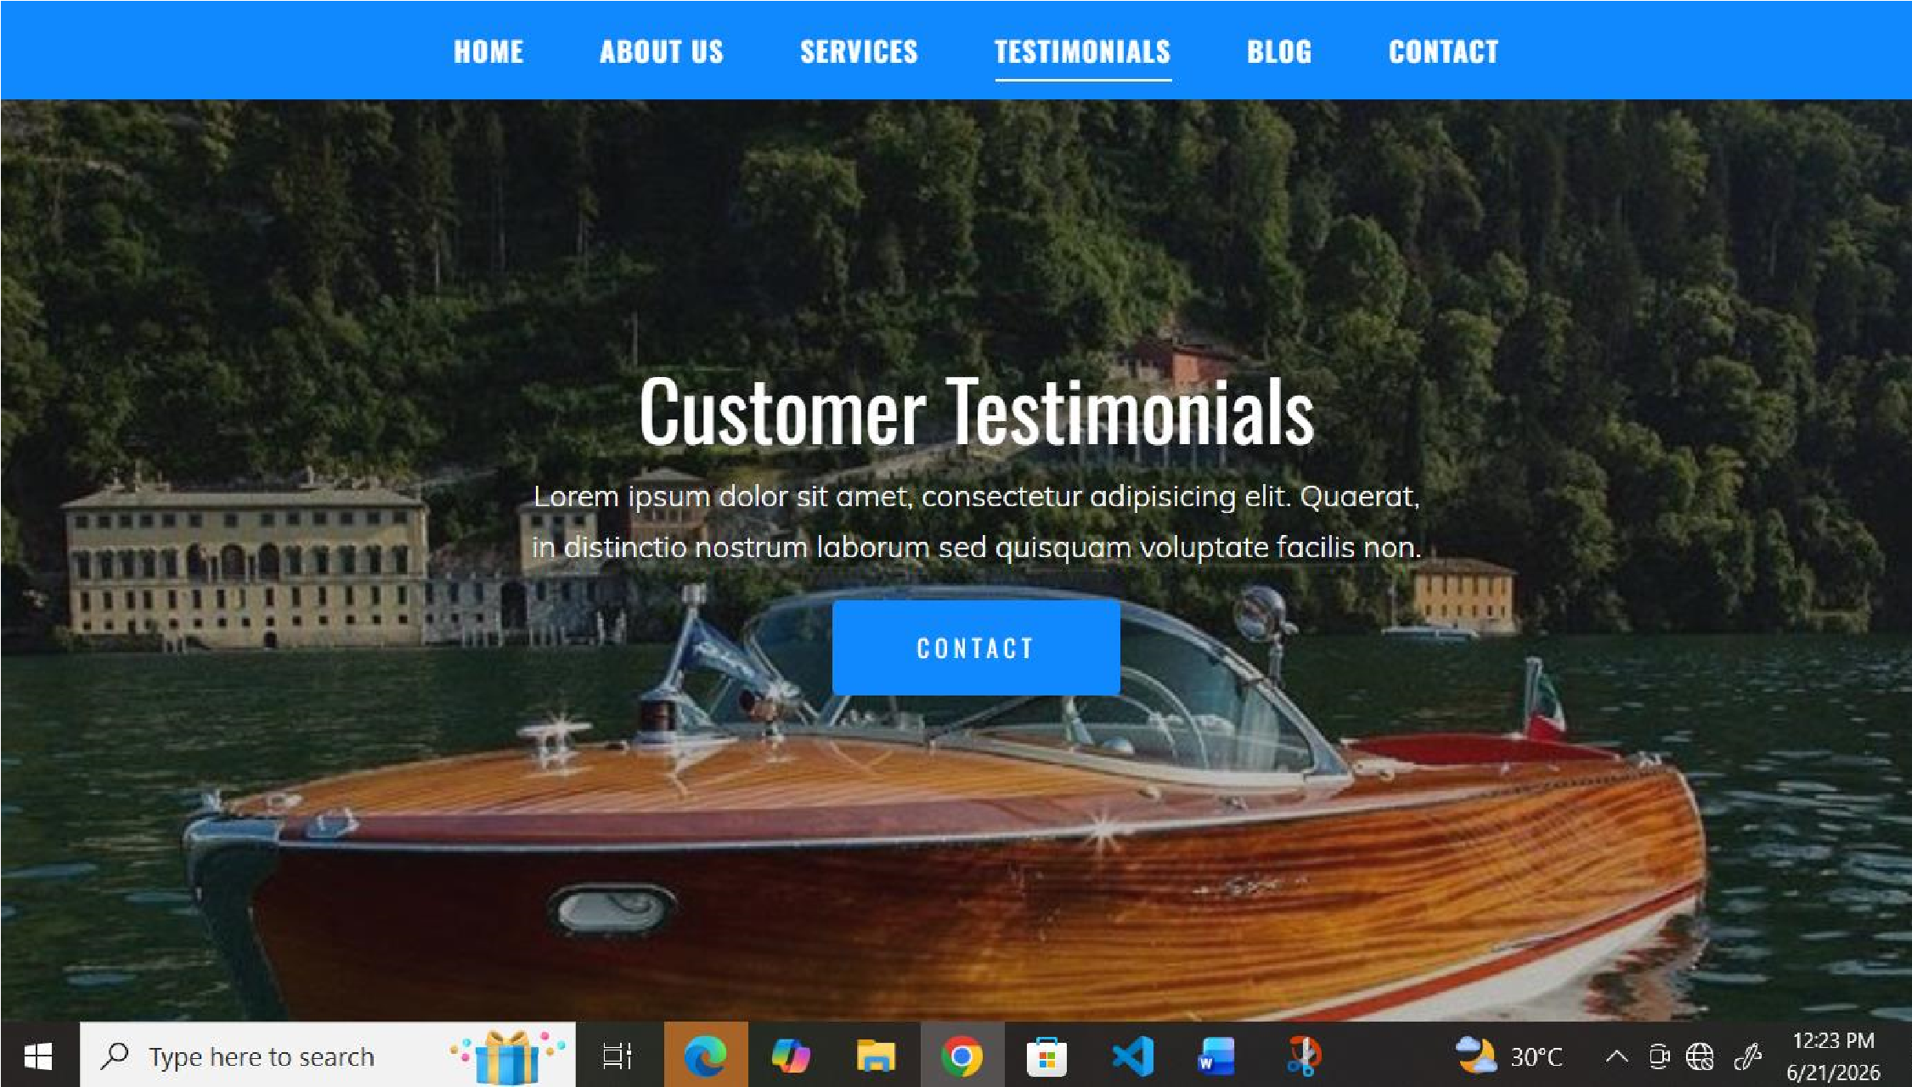
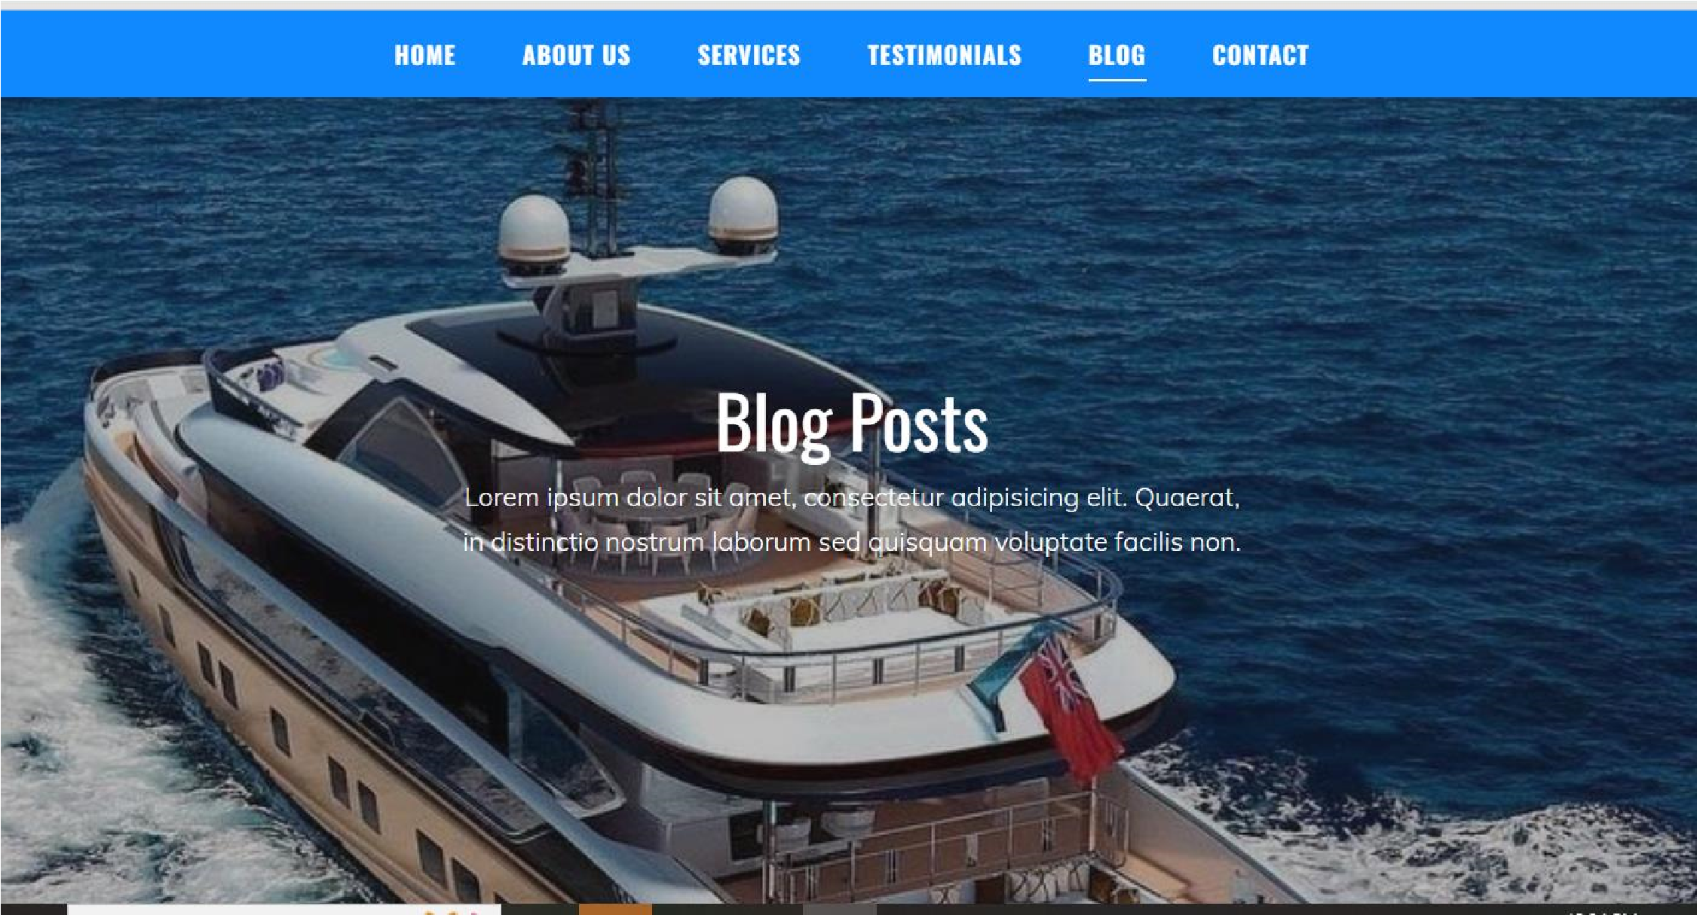
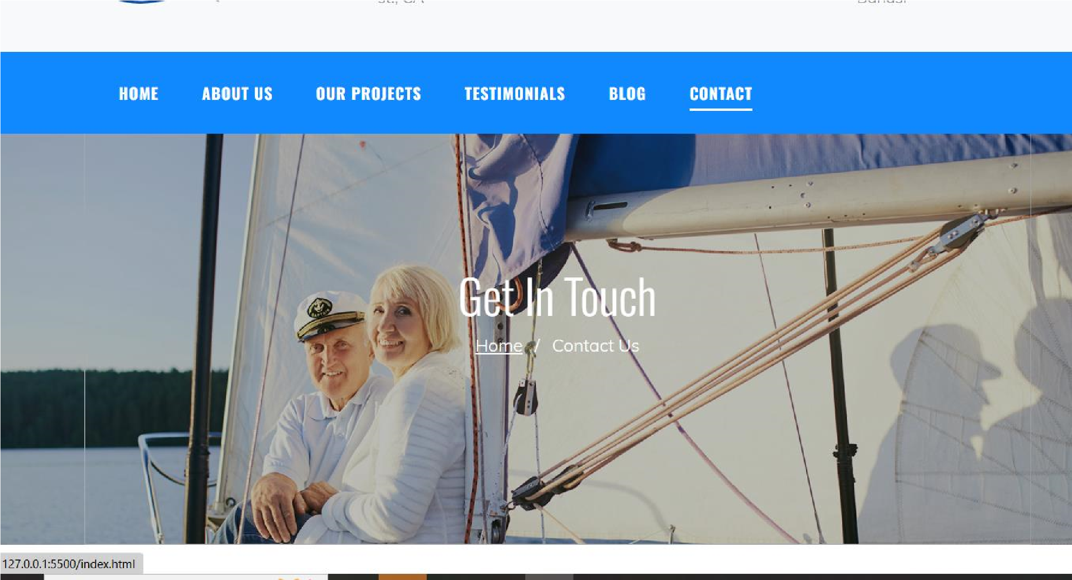
TESTIMONIALS BLOG CONTACT CODE FIGURE
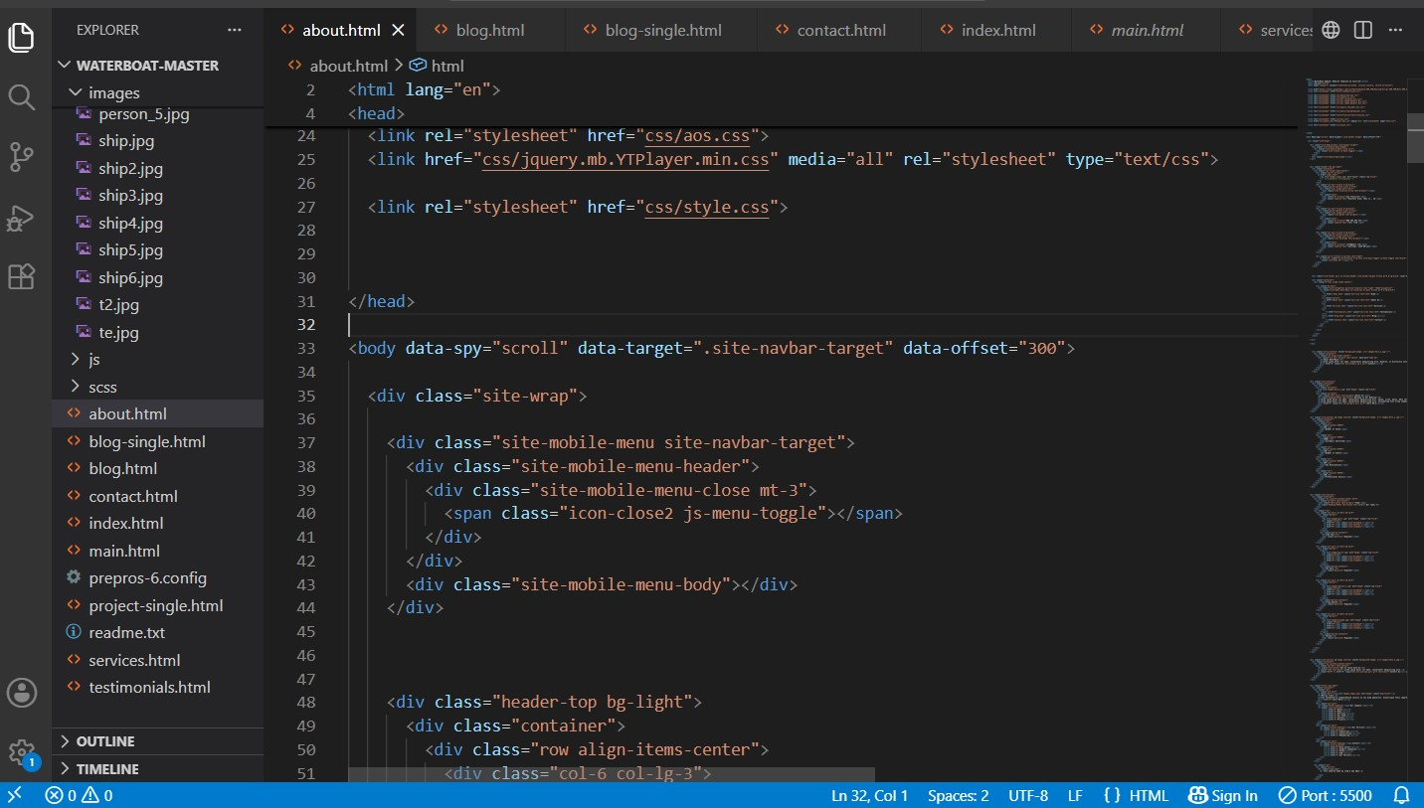

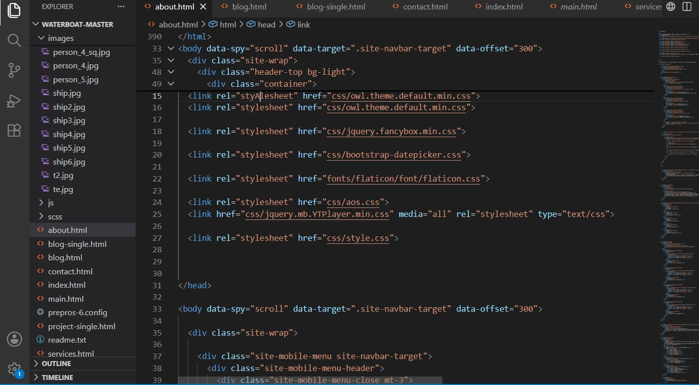

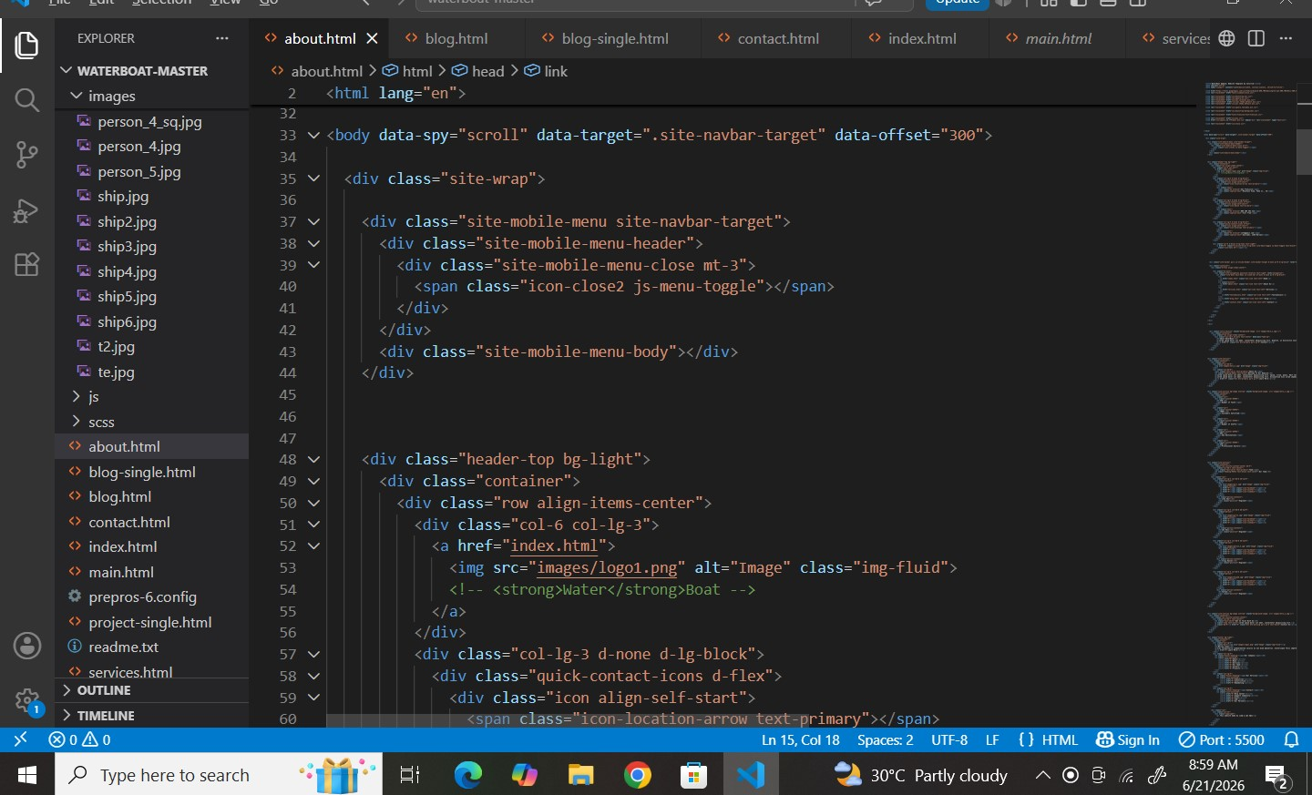
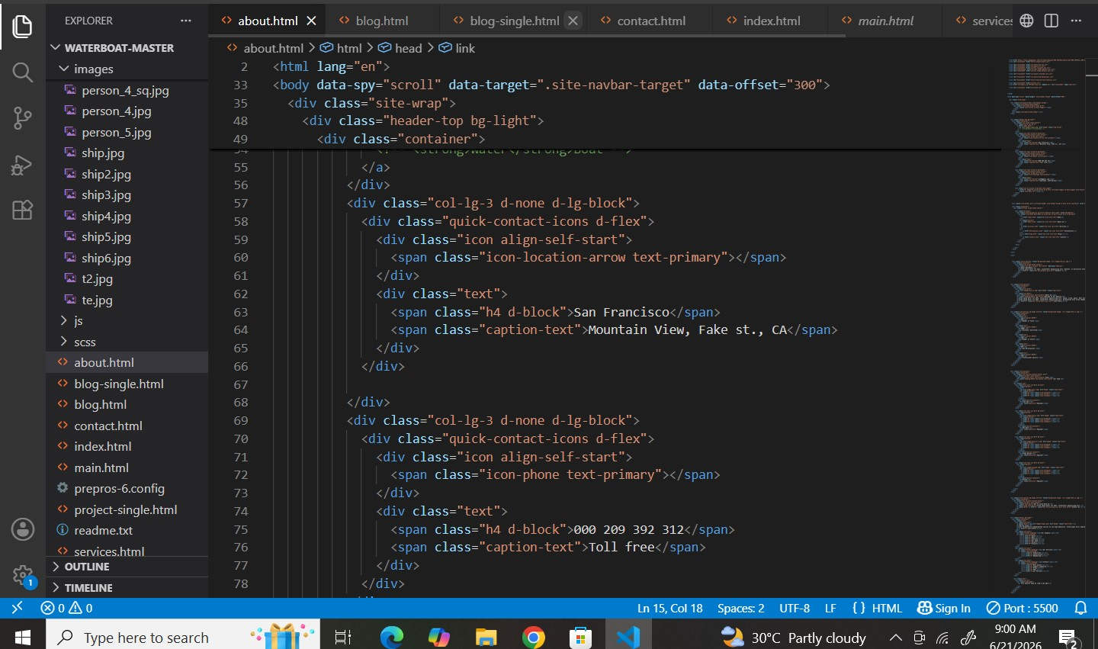

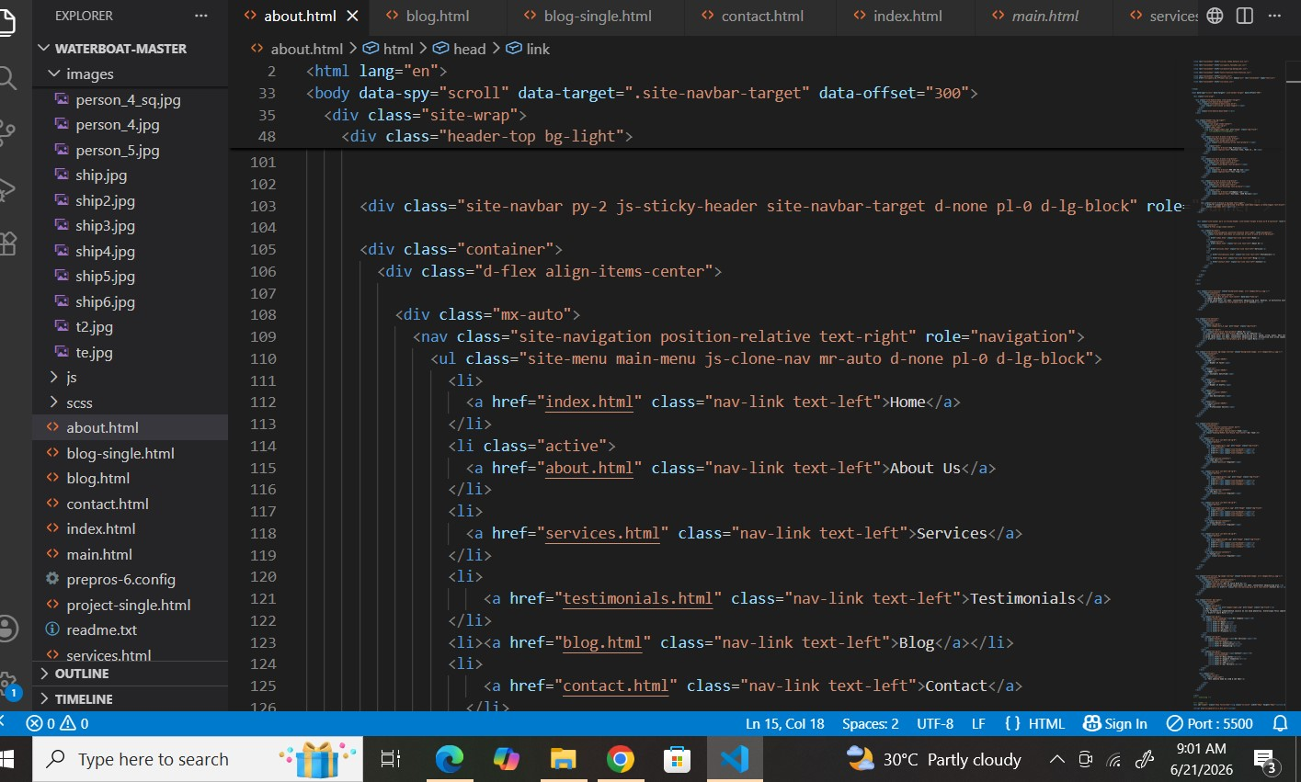

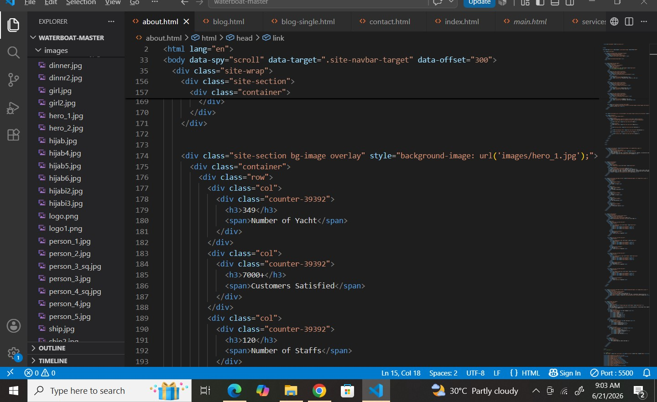
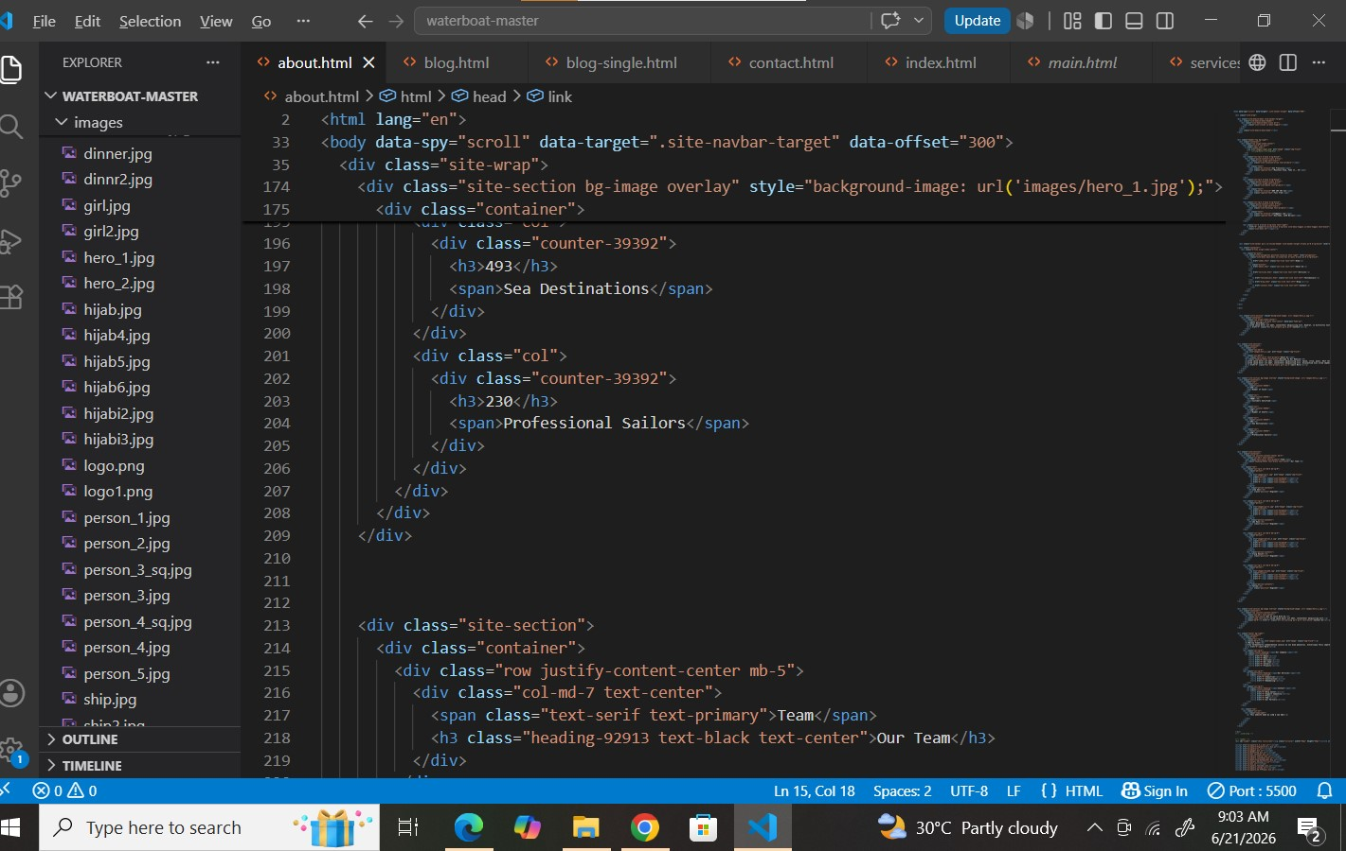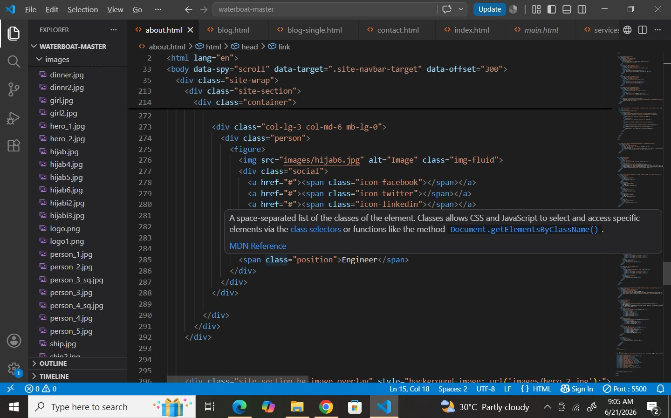

Conclusion
Ultimately, a marina fleet is far more than just a collection of boats tied to a dock; it is the operational heartbeat and primary economic engine of a modern waterfront hub. Whether serving as a gateway for recreational tourism through rentals and charters or providing essential maritime infrastructure through service and safety vessels, the fleet defines a marina’s identity and capability.
Managing a successful marina fleet requires a delicate balance of meticulous asset maintenance, strict adherence to safety protocols, and a forward-looking commitment to environmental sustainability—especially as industry standards shift toward eco-friendly propulsion and cleaner waterways. When optimized effectively, a well-run marina fleet seamlessly bridges the gap between land and water, driving local tourism, fostering a vibrant boating community, and ensuring safe, memorable access to the marine world.

